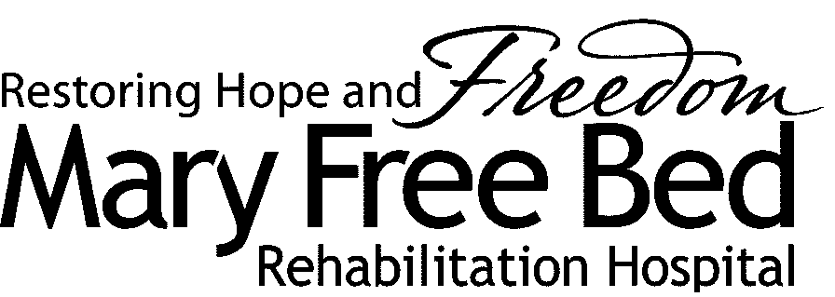
Mary Free Bed Rehabilitation Hospital
Research Institutional Review Board
235 Wealthy SE
Grand Rapids, MI 49503

NOTIFICATION OF STUDY CLOSURE

Study closure can only be done after completion of data analysis. (Do not close your study until data analysis is complete, your study database closed and the sponsor has notified you of such in writing, if applicable.)

Full Study Title:
MFB Research IRB #:
Principal Investigator:
Date of Study Closure:
Reason for study closure:
Brief summary of results :
Plan for publication/presentation :

Total # of patients enrolled or charts reviewed at this site:
Total # of patients who withdrew from the study at this site:
Are there any previously unreported adverse or unanticipated events? No Yes
If yes, please explain:

Signature of Principal Investigator__________________________________ Date: __________________

Return to: Research IRB EMAIL: research.irb@maryfreebed.com
235 Wealthy SE
Grand Rapids, MI 49503

