Workday Modules Notes
Recruiting Transactions
Introduction to Workday Recruitment
Workday Security Groups
- Primary recruiter- manages assigned job requisitions instead of all job requisitions in a supervisory organization.
- Recruiter- manages all job requisitions in a supervisory organization.
- Recruiting coordinator- coordinates interview scheduling, offer docs, etc
- Recruiting sourcer- located candidates for open positions.
- Recruiting administrator/manager

Use the Search box to search for tasks, objects (e.g., candidates, job requisitions, organizations), and reports. When you perform a search, Workday displays type-ahead predictive suggestions as well. The search results that you receive are based on your security configuration.
When using a search prefix, Workday searches all items of that type. Examples of common recruiting search prefixes include "cand:" for candidates and "jr:" for job requisitions. To view all search prefixes you have access to, enter a question mark (?) in the Search box. The Related Actions icon or Actions button (shown below) is located next to the name of an object. Once selected, it displays a menu of available actions for a given object, such as a worker, candidate, or prospect. The list of available actions depends on your security permissions.
Your Inbox contains a list of tasks assigned to you, organized in two tabs: Actions and Archive. The Actions tab displays business process tasks, approvals, and to-dos that require action. The Archive tab displays historical actions and business processes performed within the last 30 days.
Access your Notifications to review notifications regarding business processes and alerts, such as tags to a prospect's activity stream. From the Notifications page, you can filter, sort, and refresh your notifications. You can also mark all notifications as read.
The Recruiting Hub provides a centralized location where recruiting users can take action on candidates, see candidates across job requisitions, and access common tasks and reports.
The Recruiting Hub includes a collapsible navigation toolbar to provide single-click access to commonly used tasks and reports. Users can configure their own shortcuts to display in the toolbar. You can configure up to 10 shortcuts (e.g., external links, tasks, reports).
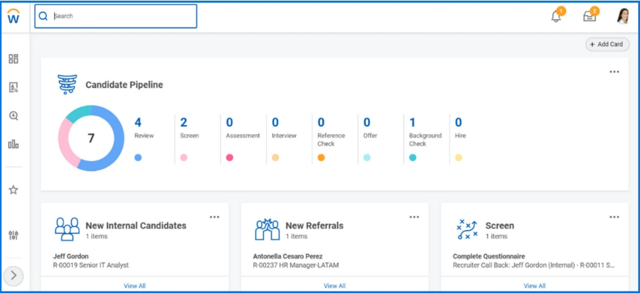
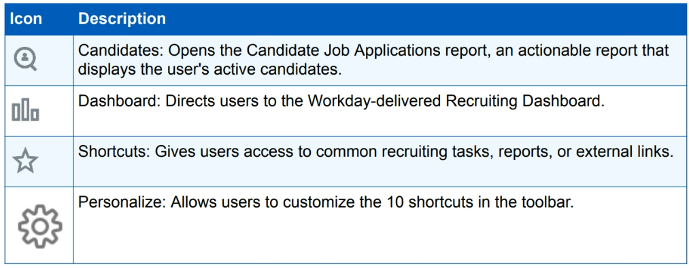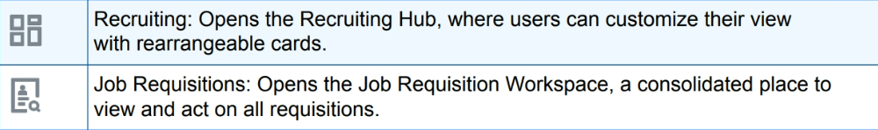

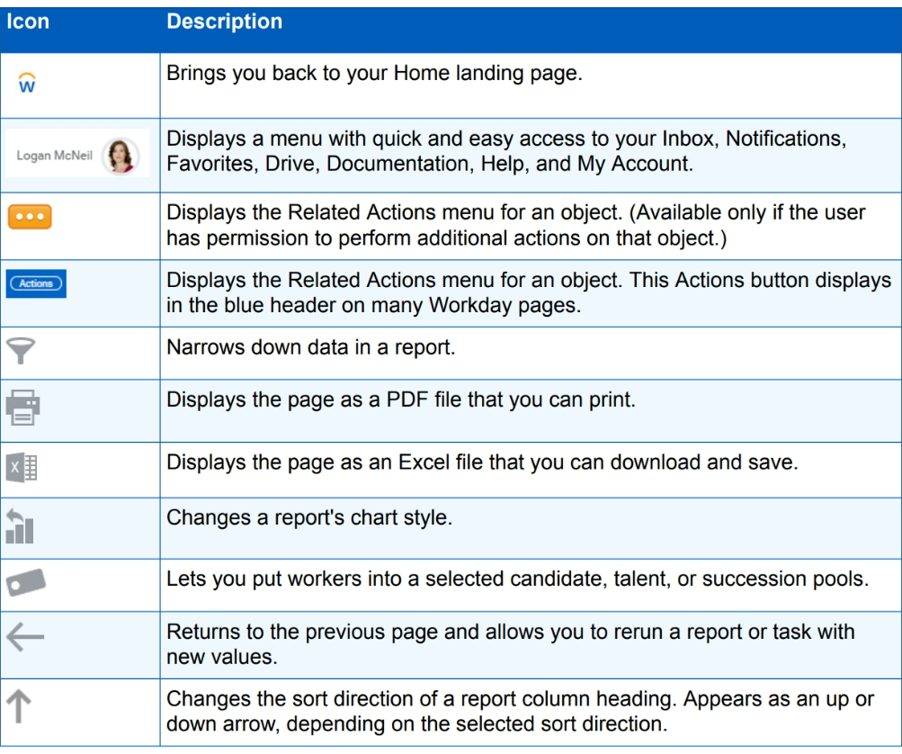
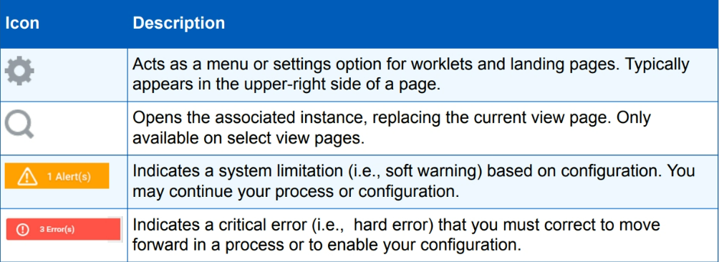
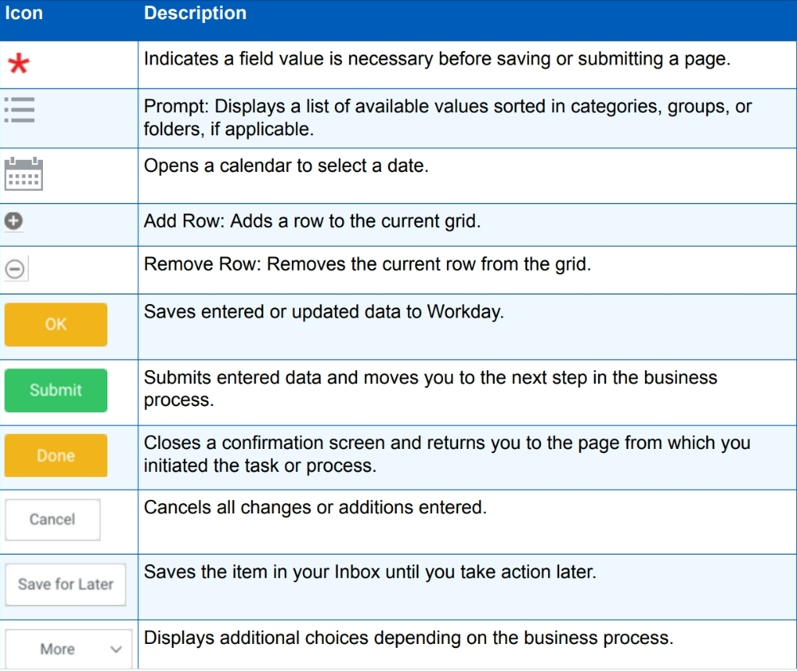

Job Requisitions
Position management: position must exist to hire into, separate hiring rules for each position
Job management: no limit on number of jobs, hiring restrictions apply to all jobs in supervisory organization, less control.
One job profile can be used for multiple positions, just defines the overarching criteria of the roles.
- Defines job associated with the worker
- General description for a job (e.g. server, bartender, manager)- positions are # of seats, job reqs are how we market out positions
- Determines worker job interests
- Default configured information into positions and requisitions associated with them
- You can assign a job profile to multiple positions or workers. Job profiles might have a one-to-one relationship with a position (e.g., CEO) or a one-to-many relationship with multiple positions (e.g., executive assistant)
- A job profile consists of many optional fields that you can track and report on, depending on your business needs. Some values, such as management level and job classification, are customer-defined. Of the many fields available during job profile creation, the only required fields are job profile name, job code, and effective date.
- A job profile consists of many optional fields that you can track and report on, depending on your business needs. Some values, such as management level and job classification, are customer-defined. Of the many fields available during job profile creation, the only required fields are job profile name, job code, and effective date. The following fields allow localization:
  - Classification, pay rate type, workers comp code, job exempt, restrict to country, certs
- You may have a one-to-one relationship between job profiles and compensation grades. When a job profile is created, the user can directly assign a compensation grade or grade profile to it, using the Compensation Grade and Compensation Grade Profile fields. The Impacted Eligibility Rules field lists eligibility rules that include the job profile.
- Workday also allows for the compensation grade range to display on job postings. You must have the compensation grade, compensation grade profile, and eligibility rules (as applicable) associated with a job requisition's primary and additional job profiles. The compensation grade range will only be visible on the job posting if you associate the compensation grade profile with a job profile.
Job requisition information
- A job requisition is a formal request to create a new position or hire into an existing position.
- Overview- provides high-level candidate information regarding pipeline, stage, and source
- Candidates- shows detailed info about candidates, including step or disposition, questionnaire scores, and contact info
- Details- displays req details, including req id, supervisory org, position, and other hiring requirements
- Qualifications- specifies various job qualifications such as competencies, certifications, language, education, and responsibilities
- Job postings- indicates the sites the job has been posted to, posting details, and available actions
- In Workday Recruiting, you can create and edit job requisitions and attach questionnaires to them. You can create job requisitions for filled and unfilled positions in organizations that use the position management or job management staffing model. Note that you can associate an open position to only one job requisition, which you use to recruit for that specific position. However, you can associate one job requisition with multiple opening
Questions/Questionnaires
- Can be attached to reqs as part of the screening process
- Limited to 50 questions
- Can score based on responses, can help with prioritizing candidates or with deciding between top candidates
- Primary versus secondary questionnaire (org versus job specific)- primary questionnaire = application. Can have questionnaires for screens, job specific info etc
JOB REQUISITION PAGE
The job requisition page provides a comprehensive, actionable view of your job requisition. The deployment team configures the profiles (i.e., tabs) based on your business needs.
Once created, you can attach primary, secondary, and supplementary questionnaires to a job requisition. Assign questionnaires to external and internal career sites from the following tasks:
• Create Job Requisition
• Edit Job Requisition
When you create a job requisition, Workday may automatically populate many fields. The source of the populated data depends on various factors:
• When you create a brand new job requisition, the job profile, position, and recruiting condition rules determine the data that defaults in.
• When copying another job requisition, data from the copied job requisition copies over. • For position management organizations, Workday configuration determines field defaults. Data will default from the most recent filled position or from position restrictions, depending on your organization's configuration.
• For job management organizations, field information defaults in from the job profile and recruiting condition rules.
• When you edit a job requisition, your changes apply to all job openings associated with the job requisition.
Can have multiple templates based on internal versus external, third party sites
Can only post an open recruiting req (cannot be closed or filled), can post from the inbox (as a step in the business process or a job requisition’s job posting tab. Creating a job req and posting a job req are two different things.
Your deployment team configured the various career sites to which you can post your jobs. Though you may have multiple external, recruiting agency, and third-party sites, you can only have one active internal career site at a time.
INTERNAL CAREER SITE
The deployment team configures your internal career site so that hiring teams can source internal talent for open jobs. You can only have one active internal career site at a time. From this site, workers can:
• Search, filter, and apply for open jobs. • Refer others. • View jobs similar to their interests. • Track their job applications. • Withdraw their application. • Create job alerts.
Workers access the internal career site using the Find Jobs report in Workday. Workers use this report to search, view details, and apply for jobs. The Find Jobs report uses facets to allow quick and easy job searching through filtering. As recruiters, you will only have one internal site to post to, while the Find Jobs report may present differently to workers based on your business needs.
EXTERNAL CAREER SITES
External career sites in Workday help you to find the best candidates for your job postings. Your deployment team may have configured more than one external career site to support specific countries, locations, or populations.
Based on configuration of the external career site, candidates can translate any of the job application pages into a language configured in your tenant.
An external career site consists of several elements:
• Job Listing page • Job Details page • Application form • Candidate Home page
Search for Jobs Page
The Job Listing page lists all jobs actively posted on that career site. It includes a list of jobs, primary locations, requisition numbers, days posted, search facets, and keyword searching capabilities to help a candidate find the best job fit for their skillset.
The Job Details page displays the specific details of a job posting, including the job posting template and job requisition details. This page also renders any social media links, About Us verbiage, and Apply buttons.
If applicants apply for a job without creating an account, they must enter their contact information and experience for each job application.
Application Form
The application form is an application wizard that guides candidates through the application process. Depending on your configuration, it may include contact information, experience, application questions, voluntary disclosures, and a final review. If the applicant signs in to Candidate Home and has applied to at least one job, Workday uses the information from their most recent job application. Workday then pre-loads this information onto the job application form for any subsequent job applications
- View a welcome message from your company.
- View pending and completed tasks.
- View and apply to similar job postings.
- View draft and submitted applications.
- Withdraw their candidacy to a job posting.
- Access notifications to tasks they receive.
- View and update contact information.
- Edit account settings.
- Create and manage job alerts.
PREVIEWING THE EXTERNAL CAREER SITE
You can preview jobs posted to an external career site using the External Posting URL link available within the job requisition's Job Posting tab. This link takes you to the actual job posting on the career website that external candidates see. Each external job posting in your tenant will have a unique URL.
POST JOB AND UNPOST JOB REQUISITIONS
When you edit a job requisition, the system does not automatically update the job posting. Instead, you must manually unpost and repost the job. If configured, the Unpost Job task will appear in your Inbox, followed by the Post Job task to refresh the career sites with the change.
Note: You only need to unpost and repost a job if the details that changed on the job requisition are visible in the job posting.
You may receive the Post Job task for the following business processes:
• Job Requisition • Job Requisition Change • Freeze Job Requisitions
You may receive the Unpost Job task for the following business processes:
• Close Job Requisition • Job Requisition Change • Freeze Job Requisitions
AUTOMATICALLY UNPOST JOBS
During the Job Application business process, Workday may be set up to automatically remove a job posting from all career sites once you make your hiring decision. The following recruiting steps may be configured with an Automatically Unpost Jobs step:
• Screen • Assessment • Interview
• Reference Check • Offer • Employment Agreement
• Background Check • Ready for Hire
Sometimes your job requisitions may have more than one opening. A job should not be unposted when the first of multiple candidates is hired. The Automatically Unpost Jobs step determines how many openings are left on the job requisition and uses the following rules:
• If only one opening remains, Workday removes all related job postings on all career sites, including both current and future-dated listings.
• If more than one opening remains, the job postings stay posted.
If there is ever a need to unpost a job early, you can manually unpost jobs.
Candidate Experience
INTERNAL JOB APPLICATIONS
Current employees and contingent workers will use the Find Jobs report to locate and read internal job posting details. From the Job Posting Details page, they can apply for the job by using their professional profile information or uploading a resume. They may need to answer any configured prescreening questions during the job application process as well.
Workers can also indicate job interests on their Worker Profile by selecting job profiles that marked as public jobs. Recruiting users can then use these job interests as a resource to find internal applicants who have an interest in a particular job within the company.
Note: An internal candidate cannot apply to the same job more than once. After an employee has applied for a job, the Apply button no longer appears on the Job Posting Details page.
Once a worker submits an internal application, the worker can:
• Monitor the status of their job application using the My Applications report from the Career worklet.
• Withdraw their candidacy from a posted job using the Withdraw Application task. • View pending and completed tasks from their Workday Inbox.
External Applicants
External candidates can search for jobs on your corporate career site or job boards from a desktop or mobile device.
1. Applicants can apply to jobs by manually entering their personal details and qualifications for each job to which they apply.
2. Applicants can upload their resume, then review the parsed information on the job application. This option often saves applicants time.
3. Applicants can apply using the Apply with LinkedIn button to quickly transfer data from their LinkedIn account. The LinkedIn profile data automatically maps to their Workday job application. Workday then assesses the content of the application and resume and identifies suggested skills.
4. Applicants can use their Candidate Home account. Candidate Home stores candidate contact and qualifications information from their previous job applications. This feature allows candidates to use their last job application for future applications. A Candidate Home account is required if additional tasks and questionnaires will be routed to the candidate through Workday
APPLICATION FORM
The application form is an application wizard that guides candidates through the application process. Depending on your configuration, the form may include contact information, experience, application questions, voluntary disclosures, and a final review. If the applicant signs in to Candidate Home and has applied to at least one job, Workday preloads the information from their most recent job application into any subsequent job applications.
EXTERNAL CANDIDATE JOB ALERTS
If enabled on the external job site, the job alerts functionality lets external candidates with an account create job alerts with specific search criteria. When a new job posting fits the criteria, the candidate will receive an automatic email notification.
CANDIDATE HOME
If configured, Candidate Home may be part of your external career sites. It enables candidates, including agency candidates, to access related information regarding their job application. Workday uses the candidate's email address as an identifier, which helps reduce duplicate candidates in Workday.
When candidates navigate to your external career site, they have the option of signing in to their Candidate Home account. Your tenant may be configured to make a Candidate Home account required for applicants. As a result, if the candidate applies without first signing in, the system prompts them to sign in with their existing account credentials or create a new account.
After the candidate creates their Candidate Home account, they may receive an email with a link to the external career site to verify their account.
If a candidate has applied to at least one job, Workday uses the contact information, education, and work experience from the first job application for any subsequent job applications. However, for each job application, a candidate will still need to attach a resume and complete any prescreening and EEO questions.
At any stage of the recruiting process, you can include additional steps (e.g., questionnaires) to gather information from candidates through their Candidate Home accounts. These items appear as tasks awaiting action in their accounts. After completion, the information flows back to the Candidate Profile for recruiting users to review. If you do not use Candidate Home, you can send these tasks to recruiting users to complete on behalf of a candidate.

Prospects, Candidates, Referrals
Workday Recruiting distinguishes between three individuals:
• Prospects: Individuals who have not applied but are interested in joining your company.
• Active candidates: Individuals who have applied to one or more job requisitions in your company.
• Referrals: Individuals who have been recommended by your employees.
Creating a prospect is a quick way of getting people into Workday Recruiting. Often, recruiters and managers meet people that are potential candidates with whom they want to nurture a relationship and determine if they are good candidates. When a prospect is linked to a job or evergreen requisition, the prospect becomes an active candidate. A person who applies through the internal or external career site also becomes an active candidate
Prospects are individuals who you want to track, but who are not associated with a specific job posting. Think of prospects as your leads for a position. Prospects can come from inside or outside your company. For example, you may create prospects from internal workers who have shown interest in jobs within the company. As a recruiter, you create your own list of prospects to monitor. The same individual can be a prospect for multiple recruiters.
Prospects become active candidates by applying for a job. You may decide to use the Invite to Apply feature for existing prospects. This feature allows candidates to complete any application and screening questions configured on the job or evergreen requisition. If a candidate applies to a job without first being a prospect, they will not have a prospect record in Workday unless a recruiter generates one.
You can also convert a prospect to an active candidate using the Create a Job Application task, which is available from the prospect profile's Related Actions. When you create a job application, all information carries over to the active candidate record, except Personal Notes. You can change or add to the resume data in this task, but you cannot change the contact information. If configured, you can share notes and collaborate with other recruiting users. You can add and view notes on candidate profiles at the job application level.
Once your jobs are created and posted, it is time to find candidates for your open positions. When candidates apply to jobs through internal or external career sites, they enter the configured Job Application business process and become active candidates in Workday.
In addition to applicants from your job postings, recruiters can source and manage candidates for the positions in your organization.
FIND CANDIDATES
The Find Candidates report enables you to view prospects, active candidates, and workers. These individuals have a professional profile that includes at least one piece of information for either education, skill, language, certification, or work experience.
From this report, you can:
• Use facets to filter your results. • Save frequently used searches. • Compare candidates. • Tag candidates and add them to a pool. • Invite candidates to apply. • Send a message to candidates.

Dynamic Candidate Pools
Criteria defines the pool membership. • When viewed, dynamic pools only display candidates who satisfy the criteria at that point in time.
Static Candidate Pools
• Candidates are manually added to the pool. • Add members from a report, or use the Tag icon from the prospect, candidate, or worker record.
• Membership will only change when you add or remove candidates.
Add Candidates to a Static Candidate Pool
A static candidate pool requires you to manually add people to the static pool. You have several ways to add members to a static candidate pool:
• Find Workers or Find Candidates faceted reports: From these reports, locate the desired candidates and add them to a candidate pool.
• Worker, prospect, or candidate record: Click the Tag icon to add individuals directly from their record in Workday.
• View Candidate Pool report: Click the Tag icon in the upper-right corner, and select a static candidate pool, other than the pool you are currently viewing. Workday adds all members in the current candidate pool to the new candidate pool you selected.
Once you add workers, you can view details about static candidate pool members.
Add Candidates to a Dynamic Candidate Pool
When creating a dynamic candidate pool, enter information on the criteria page to determine pool membership. Every time someone views the dynamic candidate pool, Workday refreshes the list of members using that criteria.
VIEWING CANDIDATES
A requisition provides three different ways to view candidates. From the job or evergreen requisition, the Candidates tab > Candidates subtab lists the candidates that are awaiting action by you, the recruiting user accessing this information. When a candidate is awaiting action by you, you can navigate directly to the task by clicking the task in the Awaiting Me column. This reduces the time that users spend searching for specific tasks in their Inbox.
When you select the All Active Candidates button in the upper-left corner, a list of all candidates still under consideration for the requisition displays. This view is a comprehensive list of active candidates, regardless of which recruiting user is responsible for the next action on a candidate. You can manage multiple candidates from any view.
To display inactive candidates, click the Inactive Candidates button next to the All Active Candidates button. The Inactive Candidates button displays only those candidates who have withdrawn their candidacy or have been rejected on this job requisition. The Inactive Candidates button only appears when there are dispositioned candidates on the requisition.

SAVED FILTERS FOR JOB REQUISITION CANDIDATE GRIDS
Recruiters have the option to save frequently used filters on the candidate grid. This feature provides a more personalized experience and saves time when reviewing candidates. Recruiters can apply one or more filters to the candidate grid. They can find their saved filters on the Saved Filters pull-down menu. Workday stores the recruiter's applied filter and column sorting selections on the candidate list grid of a specific job requisition. The selections remain after refreshing the page or navigating to a different page.
AVIGATING FROM THE CANDIDATE LIST TO THE CANDIDATE PROFILES
Once a recruiting user selects a candidate from the candidate list, they can explore their job application and use navigation arrows to move through other candidates' job applications. If a candidate is awaiting action by you, the arrow on the upper-left corner of the screen brings you back to the candidate list.
You can also use the "Jobs Applied to" field to view and navigate to the candidate's jobs and job applications if you have the appropriate security access.
NAVIGATING AMONG MULTIPLE CANDIDATE PROFILES WITHIN A JOB REQUISITION
Candidate Profiles have detailed information about the candidate's personal information and job application details. The record is organized into several sections, so you can easily find information about the candidate. These sections ensure recruiting users see relevant information. For example, you can configure your tenant to let recruiters, but not managers, access the Recruiting History section.
TAKING A SINGLE ACTION ON MULTIPLE CANDIDATES
You may have job requisitions with hundreds, or even thousands, of job applicants. To assist with managing this workload, the Candidate Job Applications report available through the Recruiting Hub allows recruiters and authorized recruiting users to filter, sort, and take the same action on multiple candidates across multiple job requisitions at once.

Job apps
THE JOB APPLICATION BUSINESS PROCESS
Your Workday Recruiting deployment team has configured the recruiting business processes for the different candidate populations. Specifically, they have determined which of the recruiting steps will appear to a hiring team member for different situations and different types of candidates.
The Job Application business process is designed for you to move candidates through your recruiting process. You select the relevant options to move a candidate forward, or appropriate disposition reasons to decline a candidate. This type of design means there may not be a specified order in which to complete steps. Depending on your business requirements, you may even be able to skip entire steps altogether
- Review Candidate is the first step in the Job Application business process. During this first step, you decide whether or not to consider the candidate for the job. There are four ways to initiate the Job Application business process: external apps, internal apps, job app created for prospect, agency submission
  - After you decide to move the candidate forward in the recruiting process, you need to designate the next step. For each subprocess of the Job Application business process, your deployment team configured the possible next steps. Such configuration lets you route candidates along different paths through the recruiting process
- Ready for Hire is the final step in the Job Application business process. You can initiate this step from any step in the Job Application business process. Once the completion step of Ready for Hire is initiated, Workday initiates a staffing business process in Workday HCM, depending on the type of candidate hired.
There are five potential completion events: • Hire Employee: External hires • Change Job: Internal hires • Convert to Employee: Convert contingent worker to employee • Contract Contingent Worker: Contingent worker hires • Add Job: Add an additional job to an existing worker
If configured, when you move an external candidate to a stage in the recruiting process that has the Change Personal Information step, Workday sends a notification to the candidate email address connected to the job application. A link routes the candidate to the external career site where they will see a pending task on their job application. From here, they can complete the requested task.
Candidate Self-Scheduling
Your Workday configuration team can configure any recruiting subprocess to allow candidates to self-schedule recruiting events like phone interviews, group interviews, onsite assessments, and orientations. If the candidate is external and the requisition has a valid calendar, the candidate receives the task in their Candidate Home.
With this functionality configured, candidates can schedule, reschedule, cancel, and view upcoming scheduled events. Recruiting users can view pending or scheduled events, and schedule, reschedule, or cancel on behalf of candidates
RECRUITING SUBPROCESSES
Subprocesses are the "possible next steps" in the overall Job Application business process. Think of subprocesses as mini workflows within the main workflow. These mini workflows are linear-you must complete the current step in order to move to the next step within the current subprocess. You will spend a lot of time within these subprocesses vetting your candidates. At the end of the subprocess, you decide whether to move forward or decline the candidate.
REVIEW CANDIDATE SUBPROCESS
The first step in the Job Application business process, known as the initiation step, is the Review Candidate step. During this step, you review a candidate's resume and decide if you want to move them to the next step of the recruiting process.
When a candidate applies for a job, the designated recruiting user will navigate to the requisition, review the resume and/or cover letter, and elect to either Move Forward or Decline the candidate.
SCREEN SUBPROCESS
Often used as a phone screen, the Screen step typically occurs early in the recruiting process to filter out candidates that do not meet basic job criteria. This step provides you with an opportunity to determine:
• If the candidate still has interest in the job. • If the candidate's qualifications match the job qualifications. • When to schedule an interview.
When a candidate moves to the Screen step, three things happen:
• The task is available in the Screen Tasks card in the Recruiting Hub. • The designated recruiting user receives the task in their Inbox. • The candidate's status is set to Screen.
ASSESS CANDIDATE SUBPROCESS
The Assess Candidate step lets you assign a status to aptitude metrics (e.g., skills tests) configured in your tenant. Depending on your configuration, you may be able to evaluate specific aptitude tests, an overall assessment, or both.
When a candidate moves to the assessment step, three things happen:
• The task is available in the Assessment Tasks card in the Recruiting Hub. • The designated recruiter receives the task in their Inbox. • The candidate's status is set to Assessment.
In the Assess Candidate step, you can assign assessment tests, a status, and a status date. The final step of the business process prompts the assigned user to Move Forward or Decline the candidate.
Assessment Assigned to a Job Requisition
If a job requisition has an Inline Assessment test, this test will trigger during the candidate's initial application, not during the Assess Candidate business process. During the application process on the external career site, the candidate goes to the third-party vendor assessment site to complete the assessment. Upon completion, the candidate returns to the Candidate Home to finish the application. An integration makes the results of the assessment available during the review stage.
INTERVIEW SUBPROCESS
The Interview step gives you the opportunity to conduct a meeting with the candidate. Depending on the situation, different candidates may require a different number of interviews. If conducting multiple interviews is a business requirement, then your Job Application business process is likely configured to let you return to this Interview step as many times as necessary.
For each round of interviews, a team of interviewers can rate and comment on the candidate. After interviews are complete, recruiters can view the ratings and comments before making a decision to conduct additional interviews or to Move Forward or Decline the candidate.
Enhanced interview functionality can link up directly to outlook versus original interview functionality where communication occurs offline
If configured, you can schedule email or push notification reminders that Workday automatically sends to candidates with an upcoming interview.
Recommended Interview Scheduling
The Recommended Interview Scheduling feature automatically generates schedule recommendations for interview schedulers. Workday displays proposed interview schedules based on multiple interviewers and locations. Use the Manage Interview Scheduling Settings task to define the interview settings. The Recommended Interview Settings tab allows you to:
• Define the earliest interview start time and latest end time for a specific job requisition. • Select a range of dates and day of the week. • Enable the order of the interviewers. • Select a location or room.
OFFER SUBPROCESS
The Offer step gives you the opportunity to create and present the candidate with the detailed information of your employment offer. Along with offer details, it can consist of the following compensation information:
• Base salary • One-time payments • Stock grants
When you move a candidate to the Offer step, four things happen:
• The task is available in the Offer Tasks card in the Recruiting Hub. • The designated recruiting user receives the task in their Inbox. • The candidate's status is set to Offer. • The system creates a pre-hire record for the candidate, as part of the initiation step of the Offer process.
Once the offer details are determined and approved, you can generate an offer letter. If configured, Workday sends the candidate the letter for their sign-off. In addition, a recruiter can document the status of the offer, such as Verbal Offer or Written Offer.
If you send the offer letter to a candidate with a Candidate Home account, the candidate will accept or decline the offer within Candidate Home. If accepted, Workday uses the resulting offer information to populate Workday Compensation when the candidate enters the Hire business process. If declined, the recruiter will receive a task to determine the next step in the offer process.
Consolidated Tasks for Offers
Workday can support your organization's high-volume recruiting needs. The Consolidate Tasks task consolidates offers and compensation events (e.g., offer, compensation, one-time payment, stock options) into a workbook. You can consolidate a maximum of 200 offer tasks into one workbook. This feature reduces the need to process tasks individually, improving recruiter efficiency.
Offer Letter Template
Your deployment team has designed an offer letter template that you will use to create offer letters. Depending on the configuration, your Offer business process may deliver the letter to both reviewers and candidates
The offer template consists of text blocks used to generate the offer content. These text blocks contain static text and fields. Fields enable you to retrieve specific data values (e.g., approved salary, business title, recruiter name) to ensure that every offer letter is customized for each candidate.
Condition rules may also be associated with these text blocks to further automate the offer process. For example, you may have a text block that refers to U.S.-specific benefits that you include in U.S. offer letters. The use of condition rules ensures that offer letters generated for other locations will not include the U.S. benefits text block.
Additionally, your offer letter layout may include other elements such as your company logo or stationary.

Offer Letter Generation
Your deployment team likely configured your system to generate an offer letter once compensation is approved. Additionally, you may have one or more Review Offer steps to ensure the offer letter is reviewed and/or signed by the appropriate reviewers in your company.
Regenerate Offer Letter
You can regenerate an accepted offer document after initiating or completing a hire for a candidate. If configured, this feature makes it easier for your recruiting users to amend offer letter details and resend offer letters to candidates. Use the Regenerate Offer Documents business process to configure components of this feature and the Regenerate Offer Documents task to regenerate the offer document.
Offer Letter Review
Having one or more Review Offer steps in your business process distributes the offer letter for review before finalization. Your company may use the Workday e-signature, DocuSign, or Adobe eSign feature to obtain sign-off.
Example: After the recruiter completes the offer letter, it goes to the hiring organization's cost center manager for review and sign-off.
Once the final review is submitted, you can send the offer letter as a task to the candidate's Candidate Home account. From there, the candidate reviews and signs the document, or declines.
With proper security permissions, you can view the offer letters from the Offer profile group of a candidate's profile.
When sending offers for approval internally, you can use the offer attachment feature to:
• Attach documents to the offer. • Control who can view and edit the attachments. • Access the documents from the candidate or worker profile.
EMPLOYMENT AGREEMENT SUBPROCESS
The Employment Agreement step provides the opportunity to simplify your global pre-hire negotiation and hire processes. In addition to job requisition data, employment agreements can include:
• Collective agreements • Compensation • Contract details
• One-time payments • Probation periods • Stock grants
When you move a candidate to the Employee Agreement step, the designated recruiting user receives an Inbox item, and the candidate's status is set to Employee Agreement. Initiation of the Employee Agreement step converts the candidate to Pre-Hire status. You can also generate employment agreements for contingent workers who apply for a requisition with a worker type of Employee.

REFERENCE CHECK SUBPROCESS
The Reference Check step gives you the opportunity to confirm the candidate's character, background, and experience by contacting personal and professional references. For external candidates, you can perform this process in Workday.
When you move a candidate to the Reference Check step, the designated recruiting user receives an Inbox item, and the candidate's status is set to Reference Check. Candidates can indicate references. Referees can respond to a questionnaire or decline. Recruiters can add and manage references. The final action for this step is Move Forward or Decline.
BACKGROUND CHECK SUBPROCESS
The background check step lets you confirm the candidate's credit, driving records, criminal records, and security clearances. Typically, companies use third-party vendors to conduct background checks. Your background check package may display the results in the Screening profile group of the Candidate Profile.
When you move a candidate to the Background Check step, the designated recruiting user receives an Inbox item, and the candidate's status is set to Background Check. This recruiting user can assign a background check package to the candidate and select a status (e.g., Pass, Fail, Pending) when they receive the vendor results. Once you obtain the background check, you then decide to either move forward or decline the candidate.
Important: Background check results are automatically received only if you have an integration built in your system. The results provided through this integration are the background check status and date. The integration also provides a link to your vendor's site, allowing you to review the background check details. If your organization does not have this integration, you will need to manually obtain the background check results. Check with your deployment team to confirm your system setup.
Initiation of the Background Check step creates a pre-hire record for the candidate

READY FOR HIRE SUBPROCESS
The Ready for Hire step is the final step in the Job Application business process before the pre-hire moves into a staffing business process. Consider this step as the "hand-off" step from one business process to another. Your configured Job Application business process determines from which steps a candidate can be moved to the Ready for Hire step. This allows you to take final actions before a hire or transfer process begins, such as automatically unposting a job or collecting final questionnaire data from the candidate.
When you move a candidate to the Ready for Hire step, the designated recruiting user receives an Inbox item. There is no Move Forward or Decline option from Ready for Hire

CANDIDATE COMMUNICATION
Once a prospect or candidate is in Workday, you have several ways to communicate with the candidate.
From the candidate profile's Related Actions > Candidate Actions, you can perform various communication activities. These may include sending something to the candidate or making notes about the candidate. Any email you send to the candidate from Workday is tracked in Candidate Communication. Note that Candidate Communication does track notifications sent as a result of the business process.
If configured, candidates and prospects can view dynamic fields in notifications. You can generate personalized, custom messages that are relevant to each individual. You can use the dynamic fields in the following notifications: Send message, invite to apply, interview reminders, custom business process notifications
SHARE CANDIDATE
With Workday, you can easily share a candidate's information with other people in your company. For example, you may find a candidate better suited for another organization, or you may want a hiring manager to review the candidate's profile. You have several ways to share a candidate:
• From the Candidate tab of the job requisition, the Job Requisition Workspace, or the Candidate Job Application, select the candidate of interest. Then click the More button and select the Share task.
• From the candidate's profile, select the Related Actions, then Candidate Actions > Share Candidate.
• From the prospect's profile, select the Related Actions, then Candidate Actions > Share Prospect.
From the Share task, select the worker with whom to share the Candidate Profile, then enter a message. Workday does not notify the candidate that you shared their profile.
SEND A MESSAGE
For any general correspondence with candidates, you can send them a message. Workday sends this message using a system-generated email address. Since this email cannot receive responses, Workday recommends including a Reply To email address in the body of the message. From the candidate's Related Actions, select Candidate Actions > Send Message to send a message.
Communication sent through the Send Message and Invite to Apply tasks is tracked in Candidate Communication. From there, you can see the message's send date and time, content, and sender. From the candidate's Related Actions, select Candidate Actions > Candidate Communication to access the information.
INVITE TO APPLY
Use the Invite to Apply task to send candidates a link to a job requisition on your external career site. From the candidate's Related Actions, select Candidate Actions > Invite to Apply, or search for the Invite to Apply task
WORKDAY MESSAGING
Workday Messaging is an Innovation Services product that provides recruiting users with an SMS channel to communicate with candidates. Recruiting users use Workday Messaging to send SMS messages to:
• External candidates • Internal candidates • Prospects
ACTIVITY STREAM
In Workday Recruiting, you can comment on prospects and job applications-much like group chat-as a way to collaborate with others involved in the hiring process. This activity stream includes comments from users with access to the prospect record or job application, as well as a history of actions taken on the candidate throughout the Job Application business process.
As the recruiter, you may take specific actions on prospects as you work with them in recruiting. Related Actions can differ depending on the circumstances for each prospect record. Many of these same Related Actions may also be available for prospect records.
CANDIDATE ACTIONS
From a prospect or candidate record, recruiters have access to various tasks from the Related Actions. Depending on what has occurred with a prospect or candidate, the available actions may vary.
As a recruiter, you may want to see the details of the entire job application history for a candidate. While the activity stream on a Candidate Profile shows job application activity, it does not show details about specific steps or any skipped steps. Use the Business Process Event History task from the candidate's Related Actions and select the Business Process section to view these additional details. This task displays information about the candidate, current steps awaiting action, and the Job Application business process history

NO-SHOW CANDIDATES
If a candidate accepts your offer, the resulting tasks move the candidate from the Job Requisition business process to a staffing event, such as the Hire business process. If the Hire business process is complete and unexpectedly, the new hire does not join your company, your company's business requirements will dictate your subsequent approach. Options available include:
• Use the Undo Move from Hire task. • Use the Report No Show task. • Terminate the new hire and create a new job requisition. • Rescind the hire.
DUPLICATE RECORDS
Sometimes, job seekers apply to more than one open position at a company and create two candidate records. Imagine that Tom Moore submits an application through the company's external career site. This application creates an active candidate record for Tom. Even though Tom was not selected for the position, his active candidate record remains in Workday. Later, a friend who is an employee of the company refers him, using the name, Tommy Moore. The referral creates a prospect record. You become interested in Tommy and complete a job application for him, which creates an active candidate record for Tommy. Workday would have the following records related to the same Tom/Tommy Moore:
• Two active candidate records (one for Tom Moore and another for Tommy Moore) • One prospect record (for Tommy Moore)
To prevent duplicate candidates in the system, Workday has both automatic and manual candidate merging functionality. When you merge two records, you select which record to merge. The other record becomes inactive but remains in the system.
AUTOMATICALLY MERGE DUPLICATE CANDIDATE RECORDS
If your deployment team configured your tenant to automatically merge duplicates, Workday automatically merges the information from the earlier candidate record into the most recent candidate record. As a result, only one candidate record remains active.
Note: If one of the two records has a source of Employee Referral, that source always becomes the source for the remaining record.
Workday will not automatically merge candidate records if:
• Both records have the source of Referral with different referring workers. • Both candidates have an account on an external career sites

MANUALLY MERGING DUPLICATE CANDIDATE RECORDS
If candidate records are automatically merged, but still display as potential duplicates, you can manually merge them.
You have several ways to determine if a candidate has a duplicate record in Workday:
• Use the Find Duplicates for Candidate report to find duplicates matching a specific candidate record.
• Access potential duplicates from the Overview profile group on Candidate Profiles. • Your deployment team may have configured your recruiting business process with a step to review duplicate candidates submitted by recruiting agencies.
From the Find Duplicates for Candidate report or the Candidate Profile, you will see a Merge button for possible duplicates. When you merge two records, Workday shows you will merge. In our earlier example, Workday recognizes that Tom and Tommy Moore are the same person.
UNMERGING CANDIDATES
You can find all merged candidates using the Merged Candidates report. From this report, you can click the Related Actions, and select Candidate Actions > Unmerge Candidate, or use the Unmerge button. When you unmerge records, Workday restores and activates previously inactive prospects and candidates.
DUPLICATE WORKERS
Workday can also identify prior or active workers who apply through the external career site. This functionality allows you to:
• Identify candidates that have worked at the company before. • Identify internal workers that have accidentally applied through the external career site. • Assess if the prior worker (candidate) is eligible for rehire. • Merge the prior worker (candidate) to their previous worker record.
The Find Duplicates for Candidates report can identify the following object types as potential duplicates for a candidate, and allows you to manually merge the two records together:
• Pre-Hires • Terminated workers • Former workers • Candidates
If configured on the external career site, applicants can enter certain information (e.g., employee ID, manager, email address, work location) to help you identify prior workers as potential duplicates.
When the system finds potential duplicates, the report indicates if the duplicate is an employee, contingent worker, pre-hire, or candidate. The report also includes a column indicating if the former worker is Not Eligible for Rehire, as flagged during the termination process in Workday HCM.
For duplicate pre-hires, retirees, terminated, or former workers, a Merge button lets you merge the candidate's record to the pre-hire or worker record. You can then reuse the prior worker information when you hire the candidate.
If the merger is incorrect or not wanted, you can use the Merge Candidates task to separate the records.
After merging, "Prior Worker" appears next to the candidate's name. Merged candidate records include a link that allows you to easily navigate to the worker's prior record.
Workday recommends monitoring the Find Duplicates for Candidate report early in your recruiting process to ensure you do not end up with duplicate worker records. If set up, this report can be a To Do step or notification in a recruiting subprocess (e.g., Screen, Assessment, Interview) or at any point before a pre-hire record is created
If configured, when a candidate is merged to a former worker or a contingent worker, Workday can use the Personal Information provided on the most recent job application when hiring the employee. If not configured, Workday will retain any Personal Data previously entered on the worker record

