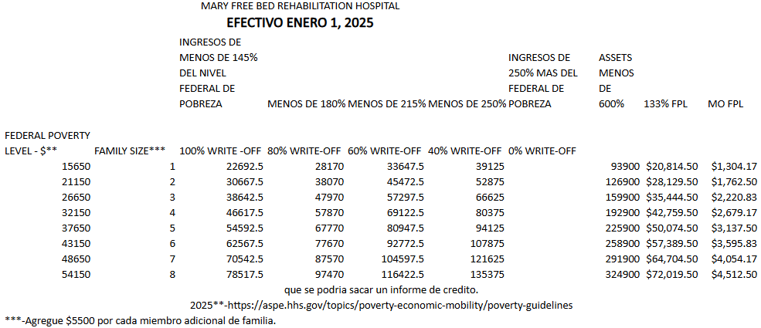

<https://aspe.hhs.gov/topics/poverty-economic-mobility/poverty-guidelines>